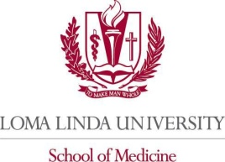

The Loma Linda University School of Medicine
certifies that

Full Name, Degree
License # (optional)
has participated in the live activity titled
(Course Title)
(Date Range)
in (location)

and is awarded (total hours attended) AMA PRA Category 1 Credit(s)TM
The Loma Linda University School of Medicine is accredited by the Accreditation Council for Continuing Medical Education (ACCME) to provide continuing medical education for physicians.
The Loma Linda University School of Medicine designates this Live Activity for a maximum of (total hours available) AMA PRA Category 1 Credit(s)TM. Physicians should claim only the credit commensurate with the extent of their participation in the activity.

The Loma Linda University School of Medicine
certifies that

Full Name, Degree
License # (optional)
has participated in the live activity titled
(Course Title)
(Date Range)
in (location)

and is awarded (total hours attended) AMA PRA Category 1 Credit(s)TM
The Loma Linda University School of Medicine is accredited by the Accreditation Council for Continuing Medical Education (ACCME) to provide continuing medical education for physicians.
The Loma Linda University School of Medicine designates this Live Activity for a maximum of (total hours available) AMA PRA Category 1 Credit(s)TM. Physicians should claim only the credit commensurate with the extent of their participation in the activity.

